**What is angular-?**

Angular is a structural framework for developing dynamic web apps. It allows developers to use HTML as a template language and allows HTML's syntax to express the application's components briefly and clearly.

Why angular?

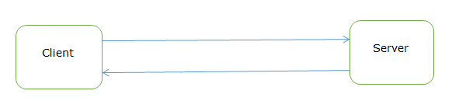

When we sent the request from browser, then it will go to server, every time when we sent the request for data, the whole page is loaded again and again, so it takes lot of time to rendering or load the pages, also performance of application will be down.

That is called as multi page application

Angular is the single page application?

It means load the single page and dynamically update the page.

You can take the example of gmail application. It will loads the single page first then you click on sent item or mail item at that time it will request the specific components. That is called as SPA.

Why angular is so popular?

It is easy to use

Provides the MVC architecture

It is compatible for both desktop and mobile application.

Two way binding

Provides the filter facility

Advantages-

It does not depend upon backend to load the HTML pages.

Easy to debug in browser

To overcome this problem, angular comes into picture.

**How to download and install Angular-**

We need Visual Studio code software to write the angular code.

Go to official sites <https://code.visualstudio.com/download>

Download the visual studio on machine.

Download the node.js <https://nodejs.org/en/download/>

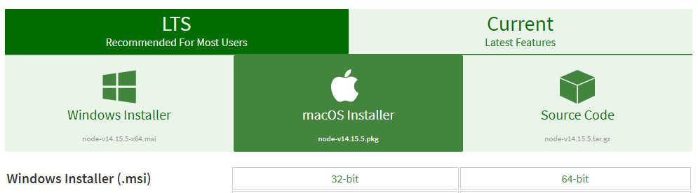

Go to windows Installer, click on 64 bit installer.

Right click on the downloaded file -> click on Install option

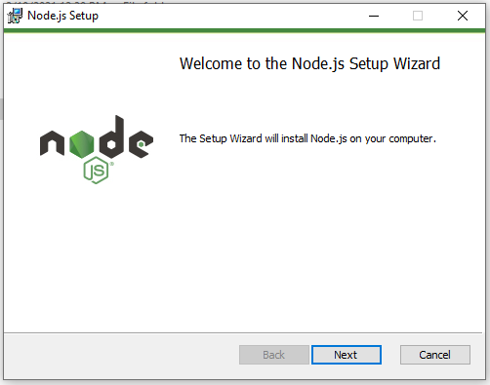

Click on Next button

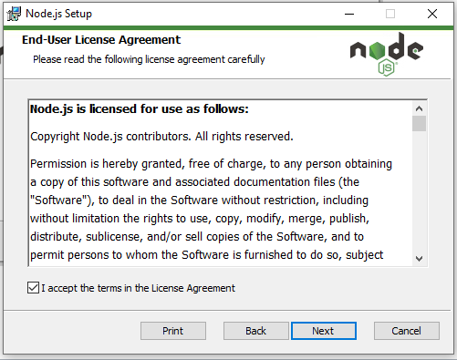

Click the checkbox I accept the terms in the license agreement then click on Next button.

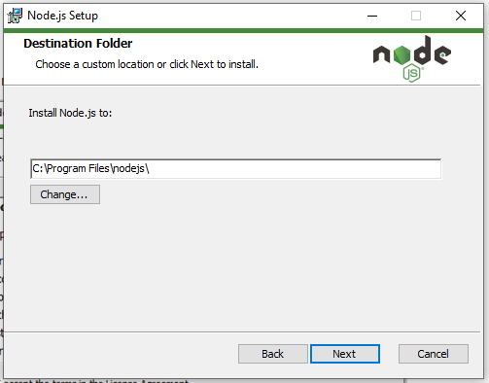

Click on Next button

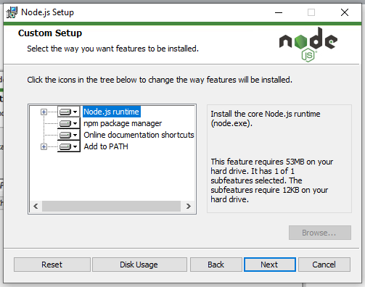

Click on Next button

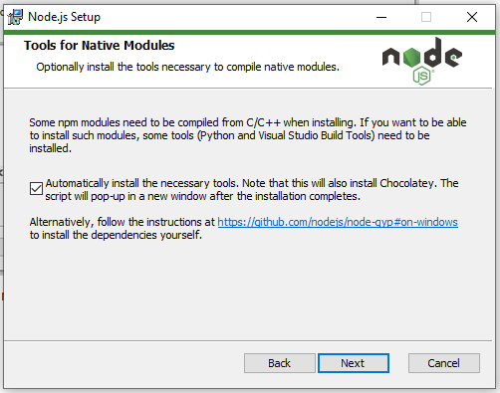

Click on checkbox then Next button.

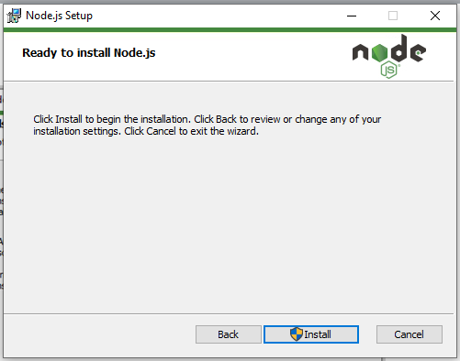

Click on Install button

Do you want to allow this app to make changes select as yes button.

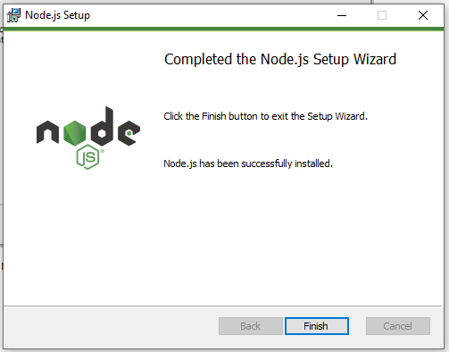

Click on finish button.

Then command prompt pop up appears just close it.

Again open the command prompt, type cmd in search box

Type node -v

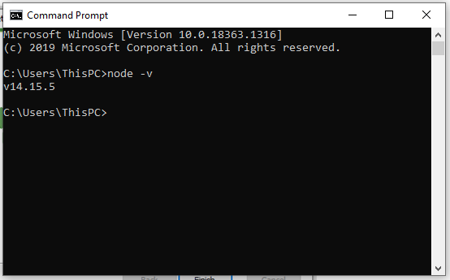

Will see the node version- v14.15.5 it mean node.js has been successfully installed on your machine.

**How to download visual studio code?**

Go to https://code.visualstudio.com/download

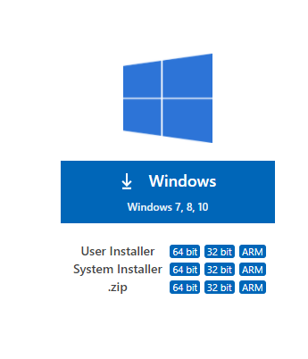

Select windows-> user installer as 64 bit (According to pc)

It will take some time to download the visual studio code software.

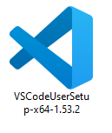

Double click on it to install the software on machine.

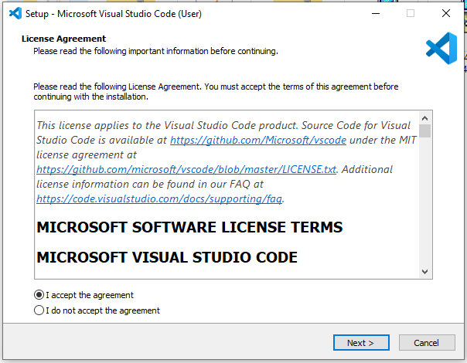

Click on Next button.

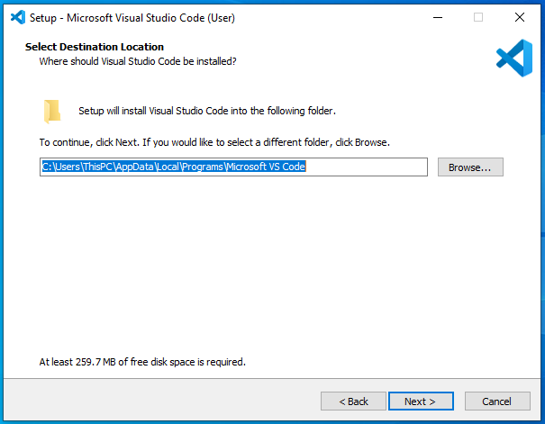

Click on Next button

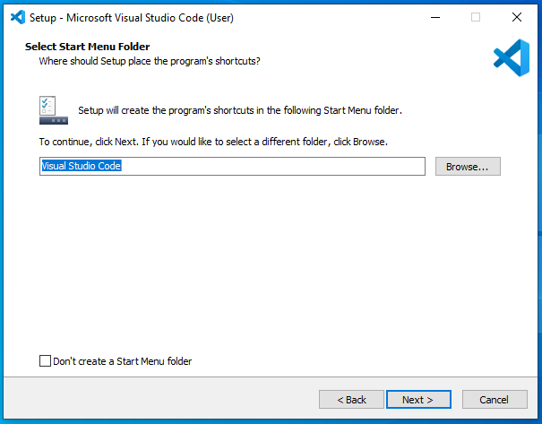

Click on Next button

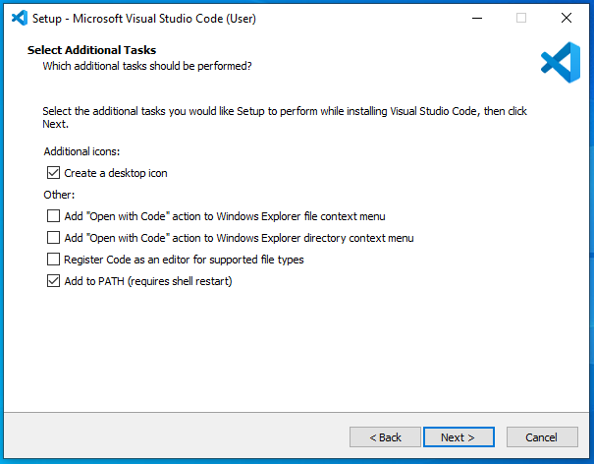

Click on create desktop icon and next button.

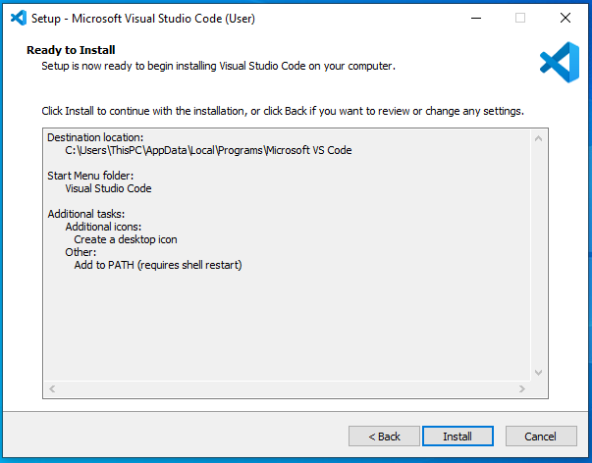

Click on install button.

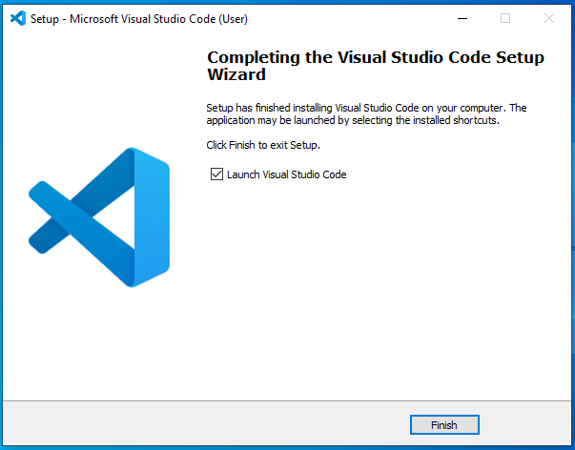

Click on finish button.

**How to create the angular project and Hello World application**

Open the visual studio code application->

Go to terminal->

Click on New Terminal->

Will display command prompt on screen

type ng new sample(Project name)

Note-if you are facing any error then Go to Page 5 and try out mentioned command.

Then it will ask for two questions

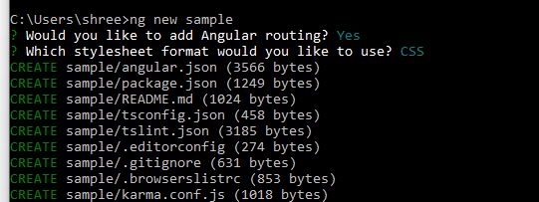

Would you like to add angular routing? Type yes

Which stylesheet format would you like to use? Type css

Then it will takes time to create the new project.

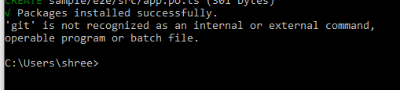

Go to file->open folder->select the created project-> click on open button then will see into visual studio code looks like as below

Project will be open into visual studio code.

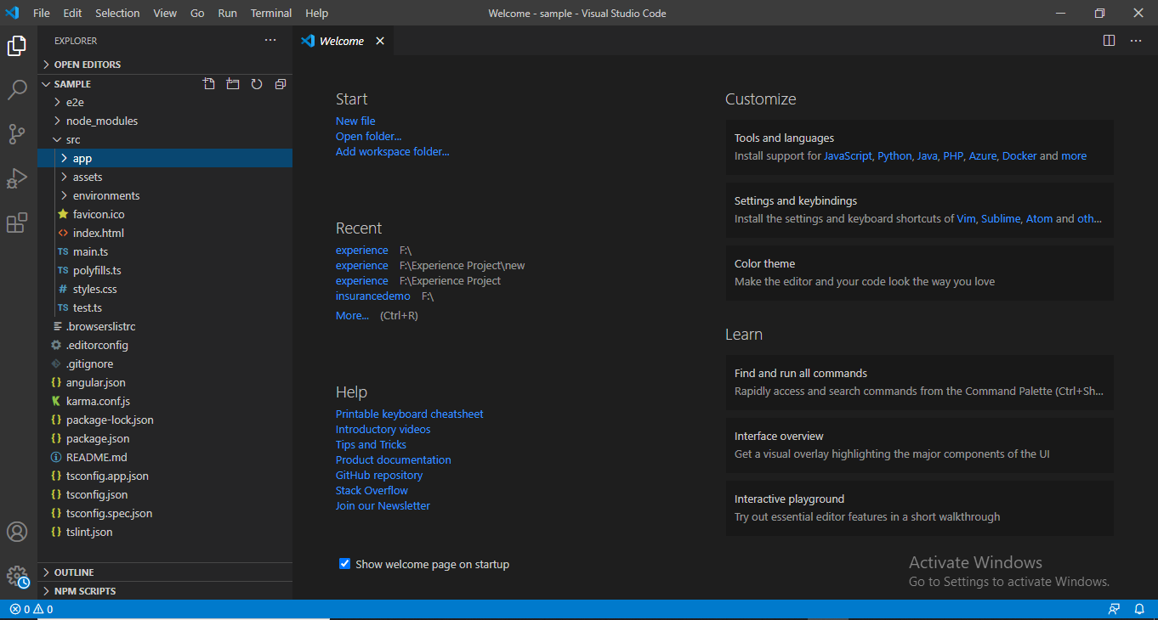

Go to terminal-> New Terminal->will open command prompt as below.

How to compile angular project

ng serve

How to run angular project

then go to browser and type <http://localhost:4200/> or

Output-

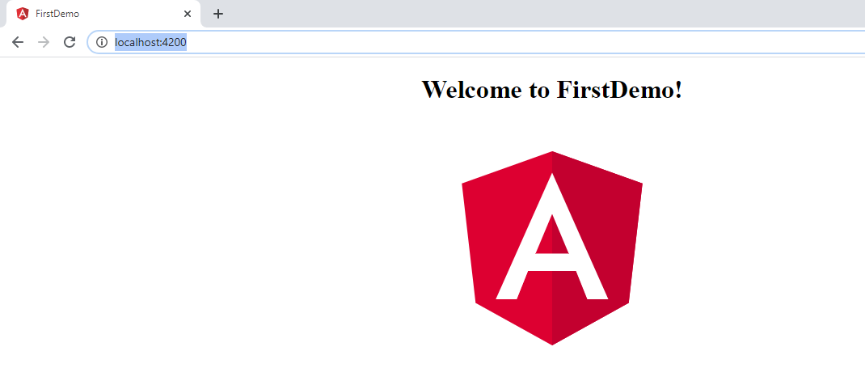

**Angular Package Structure-**

E2E folder- contain source of file to perform set of end to end test that correspond to root level application along with test specific configuration files.

Node module folder- contain set of npm package for entire workspace

Src folder- contain set of source file that are required for your application development.

Editor config folder- specifies the configuration

Angular.json folder- CLI configuration default for all the projects in the work space.

App folder – contain the component file in which application logic is present.

Assests- contain the images when you build the application.

Environment folder- target environment file

Index.html- this is the main page of application when someone visits to your site.

Main.ts - this is the entry point of your application

app/app.component.ts-Defines the logic for the app's root component, named AppComponent. The view associated with this root component becomes the root of the view hierarchy as you add components and services to your application.

app/app.component.html -Defines the HTML template associated with the root AppComponent.

app/app.component.css-Defines the base CSS stylesheet for the root AppComponent.

app/app.component.spec.ts-Defines a unit test for the root AppComponent.

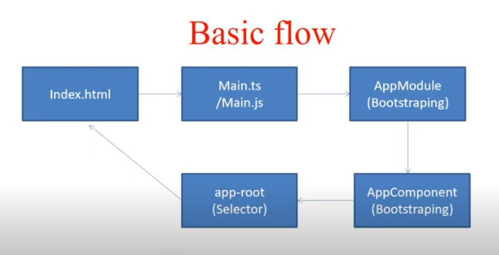

Explaination-

Main.ts->app.module.ts->app.component.ts->will call app.component.html and app.component.css file when loading ts file-> check the seletors(app-root)- go to index.html because we write there <app-root>

**Try out below command if you are facing issue**

**Windows PowerShell**

Copyright (C) Microsoft Corporation. All rights reserved.

Try the new cross-platform PowerShell https://aka.ms/pscore6

**command**

**PS C:\Users\Jeevan> ng new sample**

**Error-**

ng : The term 'ng' is not recognized as the name of a cmdlet, function, script file, or operable program. Check the spelling of the name, or if a path was included,

verify that the path is correct and try again.

At line:1 char:1

+ ng new sample

+ ~~

+ CategoryInfo : ObjectNotFound: (ng:String) [], CommandNotFoundException

+ FullyQualifiedErrorId : CommandNotFoundException

---------------------------------------------------------------------------------------------------------------------------------------

**Open Terminal in Angular and type below 2 command**

**PS C:\Users\Jeevan> npm install Set-ExecutionPolicy -Scope CurrentUser -ExecutionPolicy Unrestricted and press enter button**

npm ERR! 404 Not Found - GET https://registry.npmjs.org/CurrentUser - Not found

npm ERR! 404

npm ERR! 404 'CurrentUser@latest' is not in the npm registry.

npm ERR! 404 Your package name is not valid, because

npm ERR! 404 1. name can no longer contain capital letters

npm ERR! 404

npm ERR! 404 Note that you can also install from a

npm ERR! 404 tarball, folder, http url, or git url.

npm ERR! A complete log of this run can be found in:

npm ERR! C:\Users\Jeevan\AppData\Roaming\npm-cache\_logs\2021-12-13T11_58_54_056Z-debug.log

**PS C:\Users\Jeevan> npm install protractor conf.js then press enter button**

npm WARN deprecated request@2.88.2: request has been deprecated, see https://github.com/request/request/issues/3142

npm WARN deprecated uuid@3.4.0: Please upgrade to version 7 or higher. Older versions may use Math.random() in certain circumstances, which is known to be problematic. See https://v8.dev/blog/math-random for details.

npm WARN deprecated har-validator@5.1.5: this library is no longer supported

npm WARN saveError ENOENT: no such file or directory, open 'C:\Users\Jeevan\package.json'

npm WARN enoent ENOENT: no such file or directory, open 'C:\Users\Jeevan\package.json'

npm WARN Jeevan No description

npm WARN Jeevan No repository field.

npm WARN Jeevan No license field.

+ protractor@7.0.0

+ conf.js@1.1.1

added 154 packages from 197 contributors and audited 154 packages in 21.515s

4 packages are looking for funding

run `npm fund` for details

found 6 vulnerabilities (1 low, 1 moderate, 3 high, 1 critical)

run `npm audit fix` to fix them, or `npm audit` for details

**PS C:\Users\Jeevan> ng new sample**

? Would you like to add Angular routing? (y/N)-

Press y button

**Routing and Navigation-**

**What is routing?**

Angular router allows us to switch from one view to another view (page). It allows us to control different routes to different component and flow of data between these components called as “Routing”.

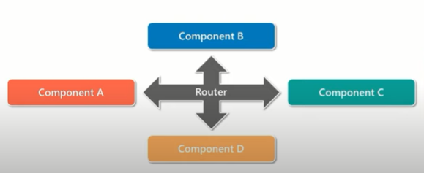

**Example**- Go to Facebook page, first page is login then move from login to home page then home page to send message, etc.

**Why we use routing?**

In traditional web application, when user type the URL in browser, HTTP request is sent to the server, which then retrieve the HTML page. For each new URL, the user is redirected to new HTML page.

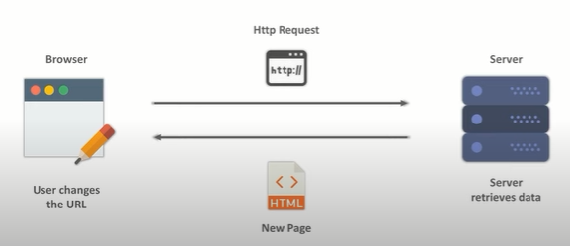

In case of single page application, we don’t load the whole application; we are only loading the part of application. This is done with the help of routers.

Note- before routing we use href tag.

Routes-Define the array of routes, each mapping URL path to component

Router- components navigations

RouterLink- It binds clickable HTML elements to routes.

RouterOutlet- which view is displayed on the particular action.

Component means login, register, about us, contact us page, etc these are components.

Let’s create the three components by using command-

Open terminal

C:\Users\ThisPC\angulardemo> - this is default path

Write the below command

C:\Users\ThisPC\angulardemo>cd src then press enter button

C:\Users\ThisPC\angulardemo\src> then write cd app as per below

C:\Users\ThisPC\angulardemo\src> cd app and press enter button

C:\Users\ThisPC\angulardemo\src\app> then write below command as

C:\Users\ThisPC\angulardemo\src\app> ng generate component login

ng g m moduleName --routing

Open the app-routing.module.ts page

const routes: Routes = [

        {path: 'addUser', component :AddUserComponent},

        {path: 'about', component :AboutComponent},

        {path: 'contact', component :ContactComponent}

];

Then go to app.module.ts page and imports AppRoutingModule as

import { AppRoutingModule } from './app-routing.module';

then import the addUser component, about and contact component as

import { AddUserComponent } from './add-user/add-user.component';

import { AboutComponent } from './about/about.component';

import { ContactComponent } from './contact/contact.component';

go to app.module.ts and declare the components.

@NgModule({

  declarations: [

    AppComponent,

    AddUserComponent,

    AboutComponent,

    ContactComponent

  ],

app.component.html

<h1>Welcome to First Angular Application</h1>

<a routerLink="/adduser">Add User Page </a>|

<a routerLink="/about">About Page details</a>|

<a routerLink="/contact">Contact Page details</a>

<router-outlet></router-outlet>

Then run the program and check the output.

If I enter localhost:4200 and press enter button then nothing will be displayed

**How to set the default page, I mean for example login page.**

Go to app-routing.module.ts and make the below change as

Suppose I want to make the default page as addusercomponent then

  {path: '', component :AddUserComponent},

And go to

<a routerLink="">Add User Page </a>

You can write * or keep ‘ ‘ empty. Routing should be matched.

Note-

Whenever you hit the URL, it will display the addusercomponent page as default.

**Parent child routing**

Now suppose in add user component page, I want to show childpagecomponent

 {path: 'adduser', component :AddUserComponent,

//add child here

        },

Then write like this

  { path: 'adduser', component :AddUserComponent,

        children:[

          { path: 'child', component: ChildrenComponent }

          ]

        },

And add-user.component.html

<p>add-user works!</p>

<a routerLink="child">Child User Page </a>

<router-outlet></router-outlet>

Then try to execute the code, when you click on add user then display the child path link and click on it. child data will be displayed.